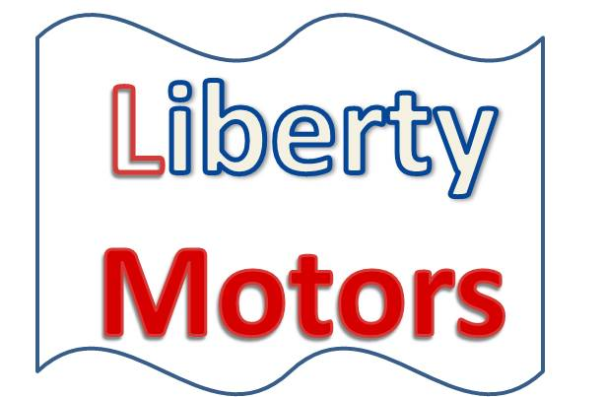

June 1, 2016

Dear

Liberty Motors is pleased to announce that we are now offering an expanded line of sports cars. Please come by the show room to view our updated inventory.

We are looking forward to seeing you soon.

Sincerely,

Jessie Pine

Auto Sales Manager